**1. Find the domain of the function using interval notation.**

f(x)= \frac{ \sqrt{x-6} }{ \sqrt{x-4}  

The interval notation for the domain of this function is [6, ∞).

Below is a graph that corresponds to this function where this domain can be observed:

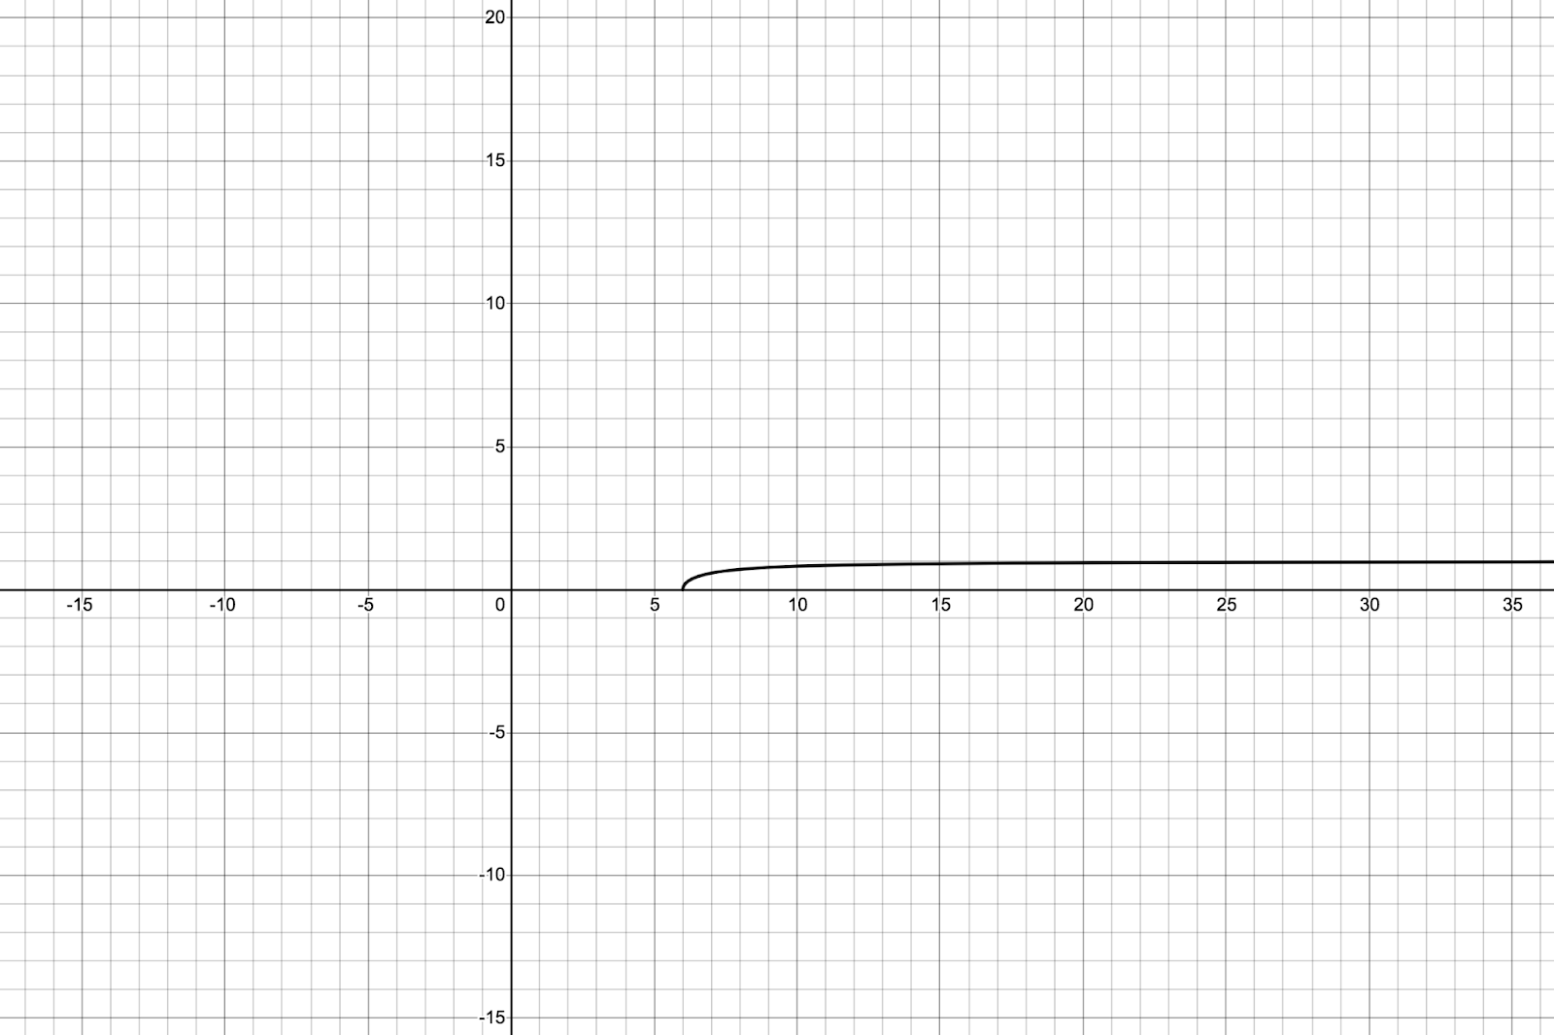

Graph created using Desmos online graphing calculator.

**2. Sketch a graph of a piecewise function. Write the domain in interval notation.**

[Suggestion: for example, go to [**www.desmos.com/calculator**](http://www.desmos.com/calculator) and write

y=x^2  for {-1 ≤ x ≤ 1} and y = 3x - 2  {1 ≤ x ≤ 3}. Then choose your own functions and have fun.]

The following domain in interval notations are for the functions provided by the assignment:

Domain in interval notation for y=x^2  for {-1 ≤ x ≤ 1} is [-1, 1].

Domain in interval notation for y = 3x -2 {1x3} is [1, 3].

Sal of Khan Academy (2015) defines a piecewise function as a function that is built from pieces of different functions over different intervals.

The following domains in interval notations, and graphs are for the choice of my own functions:

Domain interval notation for y=2x2+3x {-2x2} is [-2, 2].

Domain interval notation for y = 4x -6 {2x15} is [2, 15].

Domain interval notation for f(x) = -2 {-2x4} is [-2, 4].

Domain interval notation for f(x) = -2 {4x7} is [4, 7].

The graph below demonstrates all these functions:

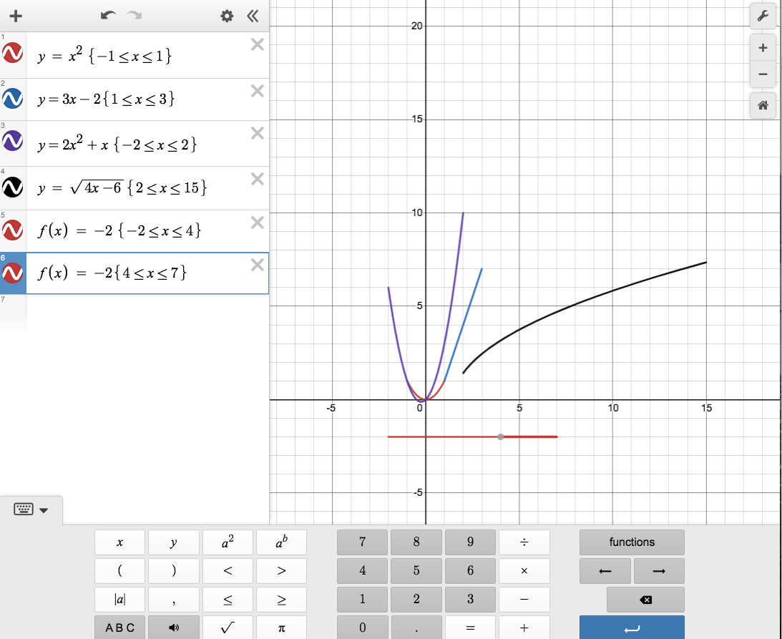

Graph created using Desmos online graphing calculator.

**3. The cost in dollars of making x items is given by the function *C*(x) = 10x + 500.**

**a. The fixed cost is determined when zero items are produced. Find the fixed cost for this item.**

C(x) is cost and x are items.

C(x) = 10x + 500

if x = 0

C(x) = 10 * 0 +500

C(x) = 0 + 500

C(x) = 500  ← The fixed cost is $500.

**b. What is the cost of making 25 items?**

C(x) = 10x + 500

if x = 25

C(x) = 10 * 25 + 500

C(x) = 250 + 500

C(x) = 750 ← The cost of making 25 items is $750.

**c. Suppose the maximum cost allowed is $1500. What are the domain and range of the cost function, *C*(x)?**

C(x) = 10x + 500

**if C(x) = 1500**

**1500 = 10x + 500**

**10x = 1500 -500**

**10x = 1000**

**x = 1000 / 10**

**x = 100 ←** max number of items that can be made based on the max cost allowed.

Domain of the cost function in interval notation is [0, 100].

Range of the cost function in interval notation is [500, 1500].

|  |  |  |
| --- | --- | --- |
|  | ITEMS | COSTS |
| MINIMUM | 0 | $500 |
| MAXIMUM | 100 | $1500 |
|  | Domain, Independent variable | Range, Dependent variable |

References:

Desmos. (n.d.). Graph Calculator. <https://www.desmos.com/calculator>

Khan Academy. (2015). Introduction to Piecewise Functions. <https://www.khanacademy.org/math/algebra/x2f8bb11595b61c86:absolute-value-piecewise-functions/x2f8bb11595b61c86:piecewise-functions/v/piecewise-function-example>